# The Practice Team

*GP Partners: Dr Jill Deacon and Dr Martin Davis supported by our employed GPs, Dr Sarah Jane Rapsey and Dr Lena Poulton. Dr Rapsey is currently on maternity leave so we have Dr Lally and Dr Herbert with us on locum cover.*

*Practice nurses: Cathy Taylor – Diabetic Nurse Specialist - and Cate Norridge – Respiratory Nurse Specialist.*

*Healthcare Assistants and Phlebotomists: Elayne Saunders, Ruth Murden and Sue Goodliffe.*

*The Administration Team is headed up by Practice Manager, Peter Darling, supported by our administrative team of Judy MacFarlane (Secretary), Elayne Saunders (Prescription Clerk), Lisa Wooster (Assistant to the Practice Manager), and the Reception Team of Jo Blackwell, Karen Hardy, Claire Smith (Team Leader)and Gill Took*

**Highfield Surgery**

**Newsletter**

**The practice in numbers:**

**6423 Patients**

**Appointments missed in January 2018:**

**50**

***Missed appointments mean that opportunities for other patients to see our medical staff are wasted.***

**April 2018**



**Save a Life Campaign – where is the nearest defibrillator?**

This is a scheme being run by our local Ambulance NHS Trust – South Central Ambulance Service or ‘SCAS’ as they are better known.

The idea is you download an App on to your phone or mobile device to find the location of the nearest defibrillator. To download the App simply go to <http://www.scas.nhs.uk/news/campaigns/savealife/> and follow the instructions. This takes about 3 minutes but could save a life.

Mark Franza, a local Police Community Support Officer, has been raising money for around a year to install 4 additional defibrillators. Three of these are in Hazlemere. One has already been installed at Hazlemere Community Centre and today one has been installed at the Esso Service Station at the Crossroads. The Esso defibrillator is situated outside which means it is available 24 hours a day

The project has been organised by Mark Franza with significant contributions from Hazlemere Fete, Hazlemere Hair, Hazlemere Parish Council, Mr Barber Shop and The Mid Counties Co-op. Thank you to all other organisations who have contributed.

**NEW PATIENT REGISTRATIONS**

Please note that we require the following for all new patient registrations before we are able to start the process of registration. Missing or incomplete documents will result in delays in the registration.

* PHOTO ID (Passport/Driving Licence)
* PROOF OF ADDRESS (Utility bill or bank statement dated within the last 3 months)
* FULLY COMPLETED REGISTRATION FORM, NEW PATIENT QUESTIONNAIRE & FAST ALCOHOL SCREENING FORM – all forms available from our website or reception desk

http://www.highfieldsurgeryhazlemere.co.uk/

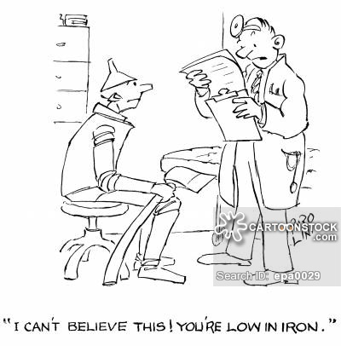

**Patient Participation Group (“PPG”)**

The PPG meet every three months at the surgery to discuss matters from the patient viewpoint and to find ways of helping the practice move forward.

The PPG has been responsible for the setting up and running of some recent events addressing the concerns that patients may have around memory loss – either for themselves or for people close to them – we have had representatives from the Alzheimer’s Society and Carers Bucks who have addressed attendees either as a group or on an individual basis and hopefully people have gone home more informed of the support that there is available to families who find themselves in this situation.

If you did not manage to attend these sessions and require some information please call the Memory Service on 01296 331749 or get in touch with the surgery.

The next event will be a presentation by one of our Practice Nurses, Cathy Taylor, on things individuals might do to prevent the potential onset of diabetes. This will be at the surgery on Thursday 26Th April from 1PM until around 2:15PM. Everyone is welcome.

**If any patient is** **interested in knowing more about the PPG or becoming an active member please get in touch with the surgery.**



Have you been watching the latest series of Great British Bake Off? Paul Hollywood and Prue Leith preside over proceedings along with Noel Fielding and Sandi Toksvig all in aid of Stand Up to Cancer. We have watched the likes of Bill Turnbull, Nick Hewer and Tim Minchin cook their best and worst bakes. Stand Up To Cancer is a charity which is hoping to prove to be a ground breaking initiative created to accelerate innovative cancer research that will get new therapies to patients quickly and save lives now.

The staff at Highfield Surgery are looking to support this charity by staging their own great Great British Bake Off and Stand Up To Cancer.

In May staff will be baking and their creations will be on sale at the Surgery to raise funds for this fantastic charity. Please come and join us.

The number of men dying from prostate cancer has overtaken female deaths from breast cancer for the first time in the UK, figures show.

An ageing population means more men are developing and dying from the disease. Prostate Cancer UK says advances in the diagnosis and treatment of breast cancer are paying off, and increased funding could benefit prostate cancer.

The biggest cancer killers in the UK remain lung and bowel cancer, with prostate now in third place.

There is currently some outstanding work being undertaken by prostate Cancer UK in highlighting this disease, particularly through their ‘March for Men’ campaign (<https://prostatecanceruk.org/get-involved/march-for-men>) and additionally raising funds for continued research into how to defeat prostate cancer.

For more information on prostate cancer please visit <https://www.nhs.uk/conditions/prostate-cancer/> or if you have any concerns in respect of your own health call the surgery and make an appointment with one of the GPs.

[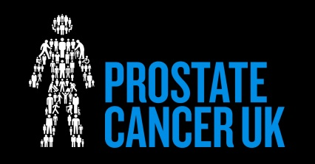](http://www.google.co.uk/url?sa=i&rct=j&q=&esrc=s&source=images&cd=&cad=rja&uact=8&ved=2ahUKEwirnt_FzMPZAhUJkywKHX3XC74QjRx6BAgAEAY&url=http://lovingleedsblog.co.uk/2017/03/24/march-for-men/&psig=AOvVaw1nZ03MxYn6dBRNDQmxrPn5&ust=1519735075432433)

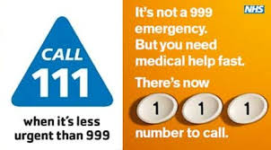

Dr Sarah Jane Rapsey